STUDY CODE: Inserted by Corps
TITLE: Evaluation of Interim Measure for 2022 Operational Passage in South Fork McKenzie
BIOLOGICAL OPINION ACTION:
• RPA 4.8 pg. 9-42. Interim Downstream Fish Passage through Reservoirs and Dams
• RPA 4.11 pg. 9-47. Assess Downstream Juvenile Fish Passage through Dams
• RPA 9.3 pg. 9-85. Fish Passage RM&E.

MANAGEMENT PURPOSE:
- Understand how regulating outlet (RO) and turbine passage routes affect size of run, timing, and distance attained for downstream migration of different life history strategies of juvenile Chinook. Use this data to inform adjustments in operations during the current year and in future years to improve successful migration through the Project and the tributary below.
- The RM&E Team and Management will review the results from the study and determine if any operational actions could improve access to downstream fish passage at Cougar Dam. Additionally, the RM&E team will determine if more data is required or identify any data gaps to determine whether the interim measures (IMs) are effective for downstream fish passage. Specifically under these proposed operations:
  - IM 17 Delayed refill to lower elevation [ not specified ]
  - IM 16 Holding pool elev at 1600’ , dropping to 1570’
3) Data on the effectiveness of the possible modified elevations and operations during spring and summer months are required to inform management on whether these operations for passage at Cougar Dam shift the diversity or size of outmigration. The data should include timing and periods of the operations, behavior, distribution, route of passage through the dam, and downstream counts of juvenile salmon [and bull trout?] to areas below the proposed tailrace screwtraps.

FUNDING SOURCE: CRFM
BACKGROUND: Previous multiyear studies of McKenzie outmigrating juvenile Chinook have described a wide variety of strategies for outmigration. Migration pulses were observed during the early first spring (fry), late first spring (subyearling), autumn, and second spring (yearling). This range of diverse life histories provided a portfolio effect that stabilized adult returns back to the Willamette River (Schroeder et al. 2016). Beeman et al (2013, 2014) noted varied responses to reservoir operations and available passage routes based on outplanted juveniles in Cougar reservoir during winter months, with the highest passage survival at the lowest reservoir elevations, from deep drawdowns, using “RO-only” passage (see Table 7 and Figure 6 from Beeman et al 2014 below). While outplanted juveniles are not fully representative of natural outmigrants, they provided important information. The outmigrants that would be tracked from screwtraps to the tributary and mainstem McKenzie River confluence represent the potential diversity of responses to currently proposed operations over the longer seasonal time frames.

Over several years of screwtrapping above and below the dam, Romer et al (2014, 2017) estimated between approximately 150,000 to 700,000 subyearlings in the river above the reservoir over the 2009-2013 brood years. In recent years, notably lower numbers of spawners have been transported above Cougar Dam. Juvenile tagging studies indicate poor juvenile survival through the Cougar Project, both Cougar Reservoir and Dam (Beeman et al. 2013). Juvenile Chinook salmon survival through the reservoir and the dam was estimated at 17.5% (11.6-25%) in 2013 (Romer et al. 2014) without inclusion of delayed mortality from dam passage. In the lowest survival years, the screwtraps captured in the range of 1,000 outmigrating juveniles, while at the higher end, as many as 175,000 that enter the reservoir, and survive passage were available to capture, both as subyearlings and yearlings. Several effects of reservoir rearing, including delayed outmigration, increase exposure to risk of copepod infection and predators; these can also affect the outmigration ‘run size’ and success.
Previous work showed most juvenile Chinook pass at night, and vary in timing over a range of RO flows, gate openings and reservoir elevations. This work will build on these earlier results to allow the Corps to ‘fine tune’ or modify the proposed actions to improve passage opportunities for the full suite of diverse life history strategies.

OBJECTIVES This study will monitor fish migrating from above Cougar Dam through available passage routes into the reaches below Cougar Dam, the lower South Fork McKenzie, and the mainstem McKenzie River. Given that operational passage options may affect the numbers, size range, and timing of outmigrants passing under different conditions, arrival timing to areas downstream of proposed screwtrapping can show how these factors vary with operational changes. Captured fish will be assigned to passage routes when caught, and the timing will be linked to the reservoir elevations and dam operations. Outmigrants can also be tracked to collect information on migration timing past the South Fork McKenzie River and approximate timing to near the confluence of the mainstem Willamette River and McKenzie River. These vary with environmental conditions, including those in the reservoir and at the dam. Two primary life history types are those juveniles that migrate to the ocean as subyearlings, and those that migrate as yearlings. From 1997-2009 the overall proportions were 21%/79% respectively for tagged fish returning as spawners (Schroeder et al 2016). Subsets within these two groups include those that are moving downstream as fry, then rearing for varied periods in the McKenzie and the Willamette Rivers (movers), leaving at later points. Those that stay until after the first year, or even into a second year before leaving (stayers) will move out quickly once passage is provided. The range of movers in years 2004-2013 was from 9% to 44%, showing these proportions vary as conditions change (see figure 1). This study will be able to track outmigration for these different strategies, and how it changes with dam passage route, timing, and operations. Given proposed efforts by USFS and ODFW to tag fish from spawning areas below Cougar Dam, the fraction that are in each group could also be compared for above and below dam spawners. The importance of a baseline data set is that the changed operations can more readily show any effect on the fraction in each category. The years for which operations run will demonstrate any shifts in the ratios due to passage changes, particularly if either strategy is diminished beyond the range seen for migration from below dam spawning areas.

Metrics
- Numbers of juvenile Chinook estimated for each route
- Peak timing of juvenile Chinook capture and median subyearling migration dates.
- Frequent fish counts (weekly or more), with size, condition, and injuries.
- Detailed reservoir and RO operations
  - Daily data for elevation, % of flow, change in total flow, gate openings
  - Hydrologic conditions above and in the reservoir during interim measures (fig 2)
- Timing of fish arrival downstream near confluence of mainstem, South Fork McKenzie
- Timing of fish outmigration to mainstem McKenzie River (e.g. at Walterville canal antenna, extending over months, or at new antenna site TBD)
- Timing of any fish outmigrating to the Willamette Falls antenna
- Movers/ stayers fraction, based on timing to lower S.Fork near confluence and to lower McKenzie, near Walterville (fig 3).
- How above change with modified passage under one of these measures:
  - IM 17 Delayed refill to lower elevation [unspecified yet]
  - IM 16 Holding pool elev at 1600’ , dropping to 1570’

SCHEDULE: 2021-2024. Covering 4 years for this study will cover a range of environmental and operational conditions. Importantly, starting in calendar year 2021 will provide data [prior to] the first year of the operations to inform upcoming decisions in following years. It can also provide information for EIS and ESA documents. During 2021, work below Cougar may provide the opportunity to include the dam passage if marked fish are recaptured, to enhance data collected in this study.

Point of Contact: Anne Mullan, NMFS

References

Beeman, J.W., H.C. Hansel, A.C. Hansen, P.V. Haner, J.M. Sprando, C.D. Smith, S.D. Evans, and T.W. Hatton. 2013, Behavior and dam passage of juvenile Chinook salmon at Cougar Reservoir and Dam, Oregon, March 2011–February 2012: U.S. Geological Survey Open-File Report 2013-1079, 48 p.
Romer, J.D., F.R. Monzyk, R. Emig, and T.A. Friesen. 2014. Juvenile salmonid outmigration monitoring at Willamette Valley project reservoirs. Task Order Number W9127N-10-2-008-0019. 61 p
Romer, J.D., F.R. Monzyk, R. Emig, and T.A. Friesen. 2017. Juvenile salmonid outmigration monitoring at Willamette Valley project reservoirs. Task Order Number W9127N-10-2-0008-0035. 49 p
Sard, N.M., D.P. Jacobson, M.J. Hogansen, K.G. O’Malley, M.A. Johnson, and M.A. Banks. 2017. Chinook salmon reintroduction above Cougar Dam: Insights from genetic parentage assignments. Presentation at the Willamette Science Review, February 8-9, 2016. Corvallis, Oregon.
Schroeder, R.K., L.D. Whitman, B, Cannon, P. Olmsted. 2016. Juvenile life-history diversity and population stability of spring Chinook salmon in the Willamette River basin, Oregon. Canadian Journal of Fisheries and Aquatic Sciences. 73:1-14.

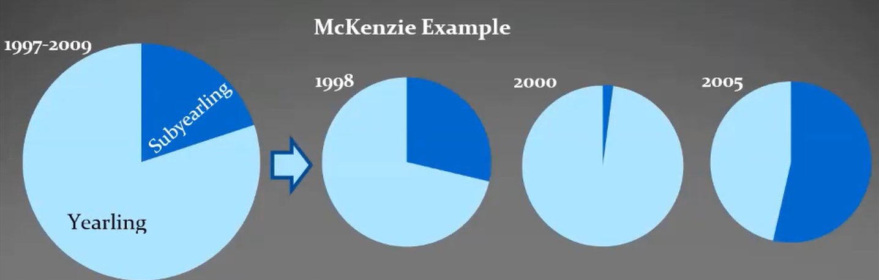
Figure 1. Run size and proportions of outmigrants in two age classes for fish caught and tagged from spawning reaches below Cougar dam. Whitman-Oregon AFS 2021
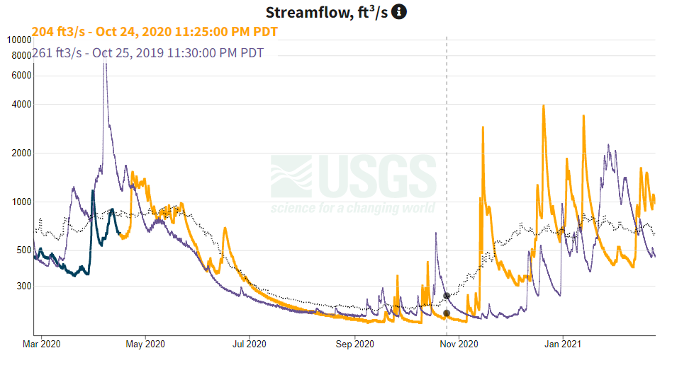
Figure 2. Contrasting conditions for two years of USGS streamflow data (yellow is 2020-2021, purple 2019-2020) from above Cougar Reservoir show how differences of up to an order of magnitude affect the hydrologic conditions juvenile Chinook experience prior to entering the reservoir. Source USGS gage 14159200
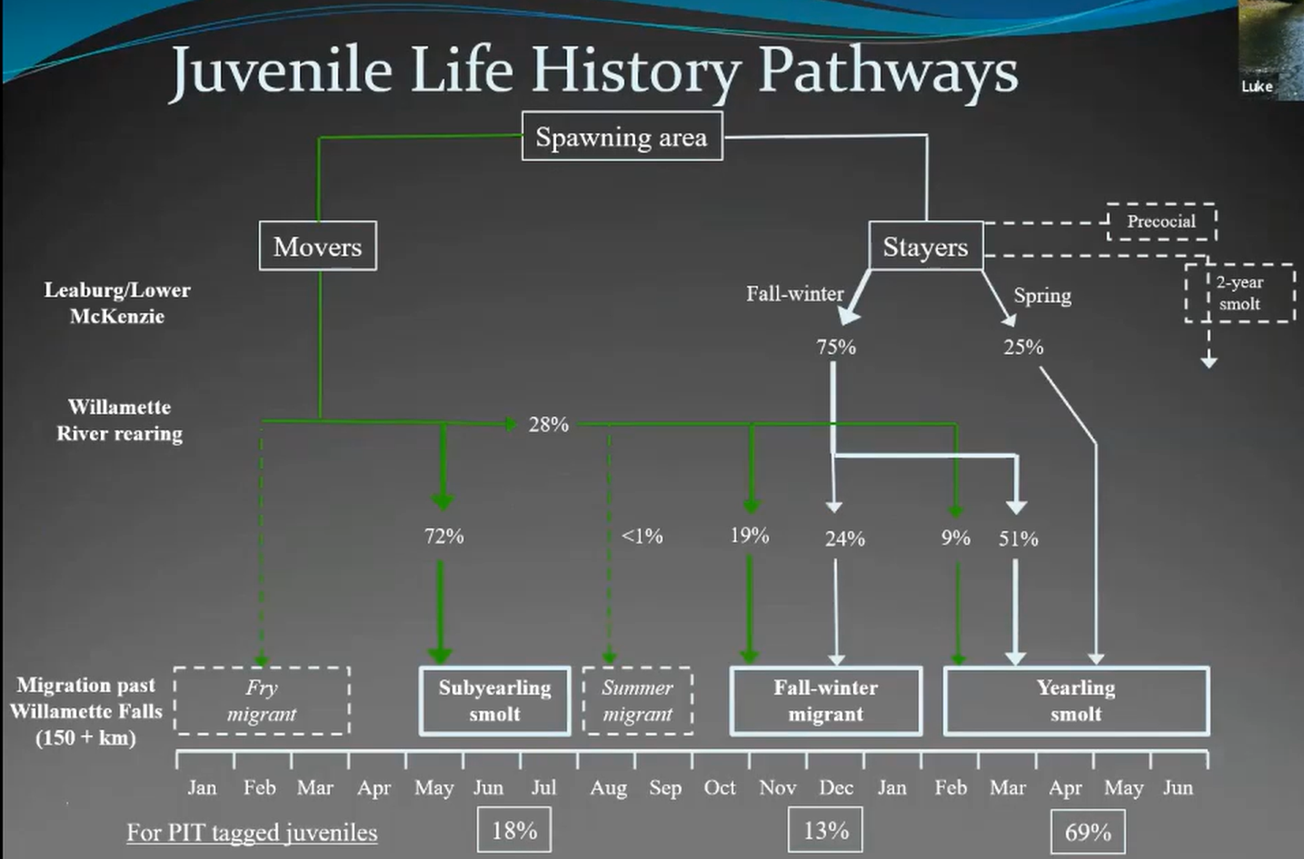
Figure 3. Range of life history strategies for juvenile Chinook leaving the McKenzie River (Schroeder et al).

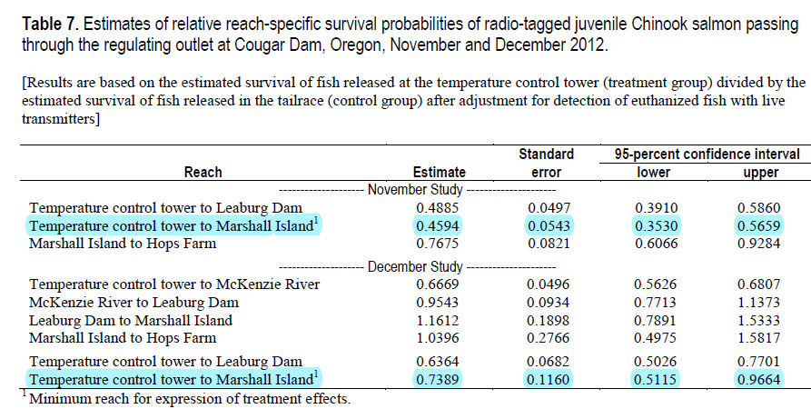
Above table of results from Beeman et al 2014, p.34.

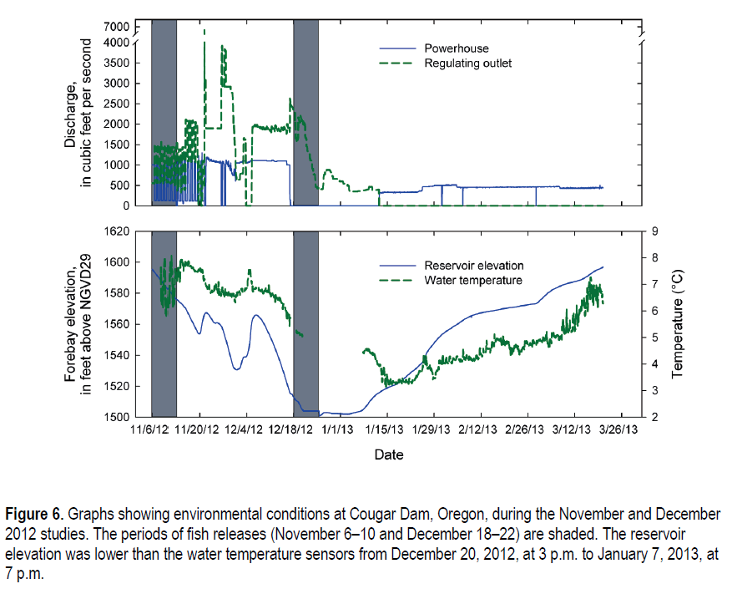
These pair of graphs, show the changes in elevation, temperature, and discharge by date, along with the split between turbine (powerhouse) and RO possible passage routes. Beeman et al 2014, p.17

